MEMO

**FROM:** Edward Ma, W0057568, 701

**TO:** Bill Cunningham

**DATE:** 11-3-2016

**SUBJECT**: DBAS 1001 Assignment #4

* **Existing System Details:**From assg4.docx, it gives a ERD diagram and Data Dictionary of said diagram.
* **Statement of Requirements**:   
  I will use the existing system details to create that data base with Access 2016 using table creation and queries creation, as well as with Oracle SQL Developer.
* **Analysis:**

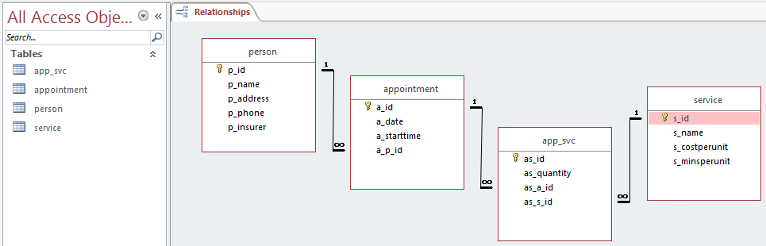***Access 2016 via Table Creation:***

***Access 2016 via Queries***

DROP TABLE app_svc

DROP TABLE appointment

DROP TABLE service

DROP TABLE person

CREATE TABLE person (

p_id INTEGER,

p_name TEXT,

p_address TEXT,

p_phone TEXT,

p_insurer TEXT,

CONSTRAINT person_p_id_PK PRIMARY KEY (p_id)

);  
  
CREATE TABLE service (

s_id INTEGER,

s_name TEXT,

s_costperunit NUMBER,

s_minsperunit NUMBER,

CONSTRAINT service_s_id_PK PRIMARY KEY (s_id)

);

CREATE TABLE appointment (

a_id INTEGER,

a_date DATE,

a_starttime DATE,

a_p_id INTEGER,

CONSTRAINT appointment_a_id_PK PRIMARY KEY (a_id),

CONSTRAINT appointment_a_p_id_FK FOREIGN KEY (a_p_id)

REFERENCES person (p_id)

);

CREATE TABLE app_svc (

as_id INTEGER,

as_quantity INTEGER,

as_a_id INTEGER,

as_s_id INTEGER,

CONSTRAINT app_svc_as_id_PK PRIMARY KEY (as_id),

CONSTRAINT app_svc_as_a_id_FK FOREIGN KEY (as_a_id)

REFERENCES appointment (a_id),

CONSTRAINT app_svc_as_s_id_FK FOREIGN KEY (as_s_id)

REFERENCES service (s_id)

);

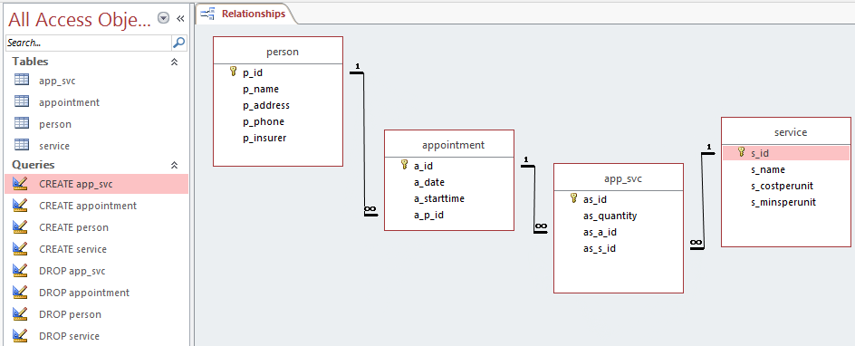***Proof of work***

***Oracle SQL Developer***

CREATE USER edma

IDENTIFIED BY w0057568

DEFAULT TABLESPACE users;

GRANT DBA TO edma;

CREATE USER dentaloffice

IDENTIFIED BY dentaloffice

DEFAULT TABLESPACE users;

GRANT CONNECT,RESOURCE TO dentaloffice;

CONNECT dentaloffice/dentaloffice

DROP TABLE app_svc CASCADE CONSTRAINTS;

DROP TABLE appointment CASCADE CONSTRAINTS;

DROP TABLE service CASCADE CONSTRAINTS;

DROP TABLE person CASCADE CONSTRAINTS;

CREATE TABLE person (

p_id NUMBER(4),

p_name VARCHAR2(20),

p_address VARCHAR2(40),

p_phone CHAR(10),

p_insurer VARCHAR2(20),

CONSTRAINT person_p_id_PK PRIMARY KEY (p_id));

CREATE TABLE service (

s_id NUMBER(4),

s_name VARCHAR2(10),

s_costperunit NUMBER(6),

s_minsperunit NUMBER(6),

CONSTRAINT service_s_id_PK PRIMARY KEY (s_id));

CREATE TABLE appointment (

a_id NUMBER(4),

a_date DATE,

a_starttime DATE,

a_p_id NUMBER(4),

CONSTRAINT appointment_a_id_PK PRIMARY KEY (a_id),

CONSTRAINT appointment_a_p_id_FK FOREIGN KEY (a_p_id) REFERENCES person (p_id));

CREATE TABLE app_svc (

as_id NUMBER(4),

as_quantity NUMBER(4),

as_a_id NUMBER(4),

as_s_id NUMBER(4),

CONSTRAINT app_svc_as_id_PK PRIMARY KEY (as_id),

CONSTRAINT app_svc_as_a_id_FK FOREIGN KEY (as_a_id) REFERENCES appointment (a_id),

CONSTRAINT app_svc_as_s_id_FK FOREIGN KEY (as_s_id) REFERENCES service (s_id));

COMMIT;

CONNECT edma/w0057568

REVOKE CONNECT FROM dentaloffice;

***Proof of work***

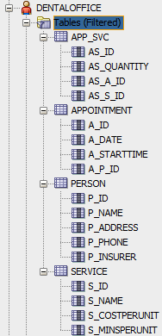

* **Recommendation**My recommendation is to use the database provided above to be develop, which will satisfy the Statement of Requirement.